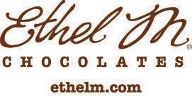
PRESS RELEASE

FOR IMMEDIATE RELEASE Contact: Iolanda Focsa, 702.882.0312
A Sweet Relief: Ethel M Chocolates Unveils Its 2020 Limited-Edition Holiday Collection to Celebrate the Season

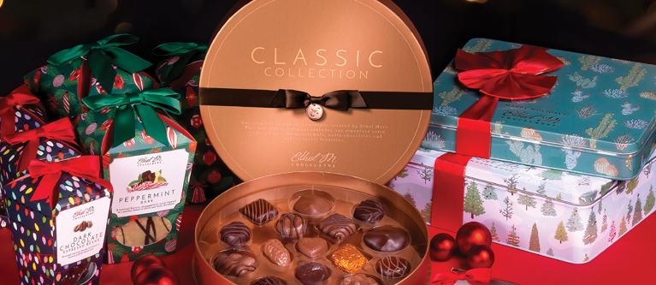

HENDERSON, Nev. (Nov. xx, 2020) – As everyone cozies up at home for the holidays, Ethel M Chocolates, the Nevada-based craft chocolate division of Mars Inc. releases its highly-anticipated 2020 limited-edition Holiday Collection. The chocolatier reimagined its packaging, creating perfectly wrapped gifts for friends and family. While still enjoying the holiday classics such as Peppermint Bark and Chocolate Coins, new products like Holiday Fudge are making their way to the top of everyone’s wish list.

“As the year winds down, we must remind ourselves the holidays are not cancelled and there is hope for the future,” said Mark Mackey, Chief Chocolatier at Ethel M Chocolates. “While time spent with loved ones will undoubtedly look different this season, we hope to be a part of your family’s tradition and bring joy into each home with our nostalgic favorites.”

In a season of giving and receiving that will look different this year, Ethel M Chocolates always delivers a wide variety of gifts, perfect for everyone on your list, near or far:

- For the Long-Distance Loved Ones
Sending something sweet to your favorite people this year is almost as good as a big hug and kiss. Gather with loved ones virtually on a Zoom-enabled Private Virtual Chocolate Tasting (starting at $40) right from the comfort of everyone’s home. Or join the New Year’s Eve Virtual Chocolate Tasting featuring the new Truffle Collection. This tasting for two is $50 and begins at 5 p.m. PST. Spaces are limited so book today at ethelm.com/virtual-experiences.

- For the Holiday Host
With small family gatherings this year, 5-piece collections such as the XO Cognac Truffles ($15) and Holiday Classics ($15) will make for the perfect table toppers. However, there is no need to shy away from the Centerpiece Collection ($95) that can take any family into the long-awaited new year.

- For the Ultimate Chocolate Lover
Give the gift of comfort this year with the Chocolate of the Month Club ($50). Each month, a personally curated collection of artisanal chocolates will be delivered to their door and topped with a bonus surprise. Subscriptions can be purchased in increments of three, six or 12 months.

- For the Kids
Kids will love the brand-new Holiday Fudge ($15), covered in creamy milk chocolate and rich dark chocolate. Each collection comes with five pieces, perfect for monitoring the famous holiday sugar rush.

- For Las Vegas Fans
Place a bet you won’t lose with the Taste of Las Vegas tin ($35), filled with classic flavors that celebrate fabulous Las Vegas, such as the Almond Butter Krisp, Satin Crèmes and chewy Caramels.

- Stocking Stuffers
Fill those stockings with seasonal favorites such as Dark Chocolate Espresso Beans ($15), Peppermint Bark ($20), Dark Chocolate Almonds ($15).

- For Local Las Vegans
Give the gift of making a new memory with one of our two, new holiday events in November and December. For the kids in your life, treat them to Sweets with Santa ($25/person) in which guests will sit socially distanced with Santa and taste chocolates, sip on hot chocolate and get a picture with him. And for coffee lovers, enjoy a tasting pairing of Ethel M Chocolates and Magnum Coffee seasonal favorites ($35/person). Dates for both events are limited so visit ethelm.com/holiday-packages to reserve a spot before they’re gone.

Retail Locations
Ethel M Chocolates’ Flagship Store, Factory and Cactus Garden are located in Henderson, Nevada with another store at Town Square Las Vegas, Nevada. Additionally, chocolate lovers can visit the Ethel M Chocolates Gift Shop inside the California Hotel & Casino in Downtown Las Vegas and McCarran International Airport at Gates C and D in Terminal 1.

For the full chocolate catalog and sweet news, please visit www.EthelM.com and follow us on Facebook, Twitter, Instagram and Pinterest.

About Ethel M Chocolates
Ethel M Chocolates are manufactured by Mars Wrigley, dedicated to creating authentic chocolates with no artificial preservatives. Ethel M Chocolates are available in multiple locations throughout Southern Nevada, online at www.EthelM.com, or by phone at 800-438-4356. The Ethel M Chocolate Factory and Botanical Cactus Garden are located at 2 Cactus Garden Drive in Henderson. For more information on the Botanical Cactus Garden, events, store hours, locations and ordering products, please visit us online or follow us on Facebook, Twitter, Instagram and Pinterest.

About Mars, Inc.
Mars is a family-owned business with more than a century of history-making diverse products and offering services for people and the pets people love. With almost $35 billion in sales, the company is a global business that produces some of the world’s best-loved brands: M&M’s®, SNICKERS®, TWIX®, MILKY WAY®, DOVE®, PEDIGREE®, ROYAL CANIN®, WHISKAS®, EXTRA®, ORBIT®, 5TM, SKITTLES®, UNCLE BEN’S®, MARS DRINKS and COCOAVIA®. Mars also provides veterinary health services that include BANFIELD® Pet Hospitals. Headquartered in McLean, VA, Mars operates in more than 80 countries. The Mars Five Principles – Quality, Responsibility, Mutuality, Efficiency and Freedom – inspire its more than 85,000 Associates to create value for all its partners and deliver growth they are proud of every day.
For more information about Mars, please visit www.mars.com. Join us on Facebook, Twitter, LinkedIn, Instagram and YouTube.

###

Media Contact:
BRAINTRUST
Iolanda Focsa, 702.882.0312
iolanda.focsa@braintrustagency.com

Holiday Collection 2020 Product List

New to the 2020 Holiday Collection:
- Holiday Fudge Collection, featuring the limited edition holiday fudge covered in our creamy milk chocolate and rich dark chocolate. $15 for a 5-piece box with a red ribbon.
- Holiday Classics Collection, featuring everyone’s favorite holiday flavors: White Chocolate Pumpkin Spice, White Chocolate Peppermint Silk, Dark Chocolate with Crème De Menthe Liqueur, Dark Chocolate EggNog, and Milk Chocolate Pecan Pie. $15 for a 5-piece box with a red ribbon.

Holiday Gifts
- Dark Chocolate Covered Espresso Beans, roasted espresso beans wrapped in luscious dark chocolate. $15 for 6-ounces in a decorative box and bow.
- Peppermint Bark, a seasonal favorite of crushed peppermint candy layered in a perfect blend of white and dark chocolate. $18 for 8-ounces in a decorative box and bow.
- Dark Chocolate Covered Almonds, savory roasted almonds covered in rich, smooth dark chocolate. $15 for 6-ounces in a decorative box and bow.
- XO Cognac Truffles, Remy Martin XO Cognac blended into a traditional dark chocolate ganache, made with just cream, a touch of salt and natural vanilla. $15 for a 5-piece box. Presented in a copper gift box with a red ribbon.
- Chocolate Coins, milk, dark and white chocolate coins are always a good idea for the holidays, sold in a 4.48-ounce bag, tied with a red bow for $15.
- Gourmet Hot Chocolate Tins, rich hot chocolate with 100% gourmet chocolate shavings in a decorative tin and red bow. 14-ounces for $25.
- Design Your Own Cactus Lights Tin, select favorite chocolate flavors to create a personalized assortment wrapped in a keepsake garden tin. $40 for a 16-piece box.
- Merry & Bright Custom Collection, create a personalized chocolate assortment from over 30 chocolate varieties available. $50 for a 24-piece box. Presented in a medium copper box with a red ribbon that says “Merry & Bright”.
- The Centerpiece Collection, the grand finale for a family get-together, 80 pieces of assorted signature chocolates in a stunning copper box for $95.

