PRESS RELEASE

FOR IMMEDIATE RELEASE Contact: Iolanda Focsa, 702.882.0312

ETHEL M CHOCOLATES’ 27th ANNUAL HOLIDAY CACTUS GARDEN LIGHTS RETURN
NOVEMBER 6

Guests Can Experience the Annual Lighting Ceremony Virtually and Reserve Their In-Person Garden Visit Online

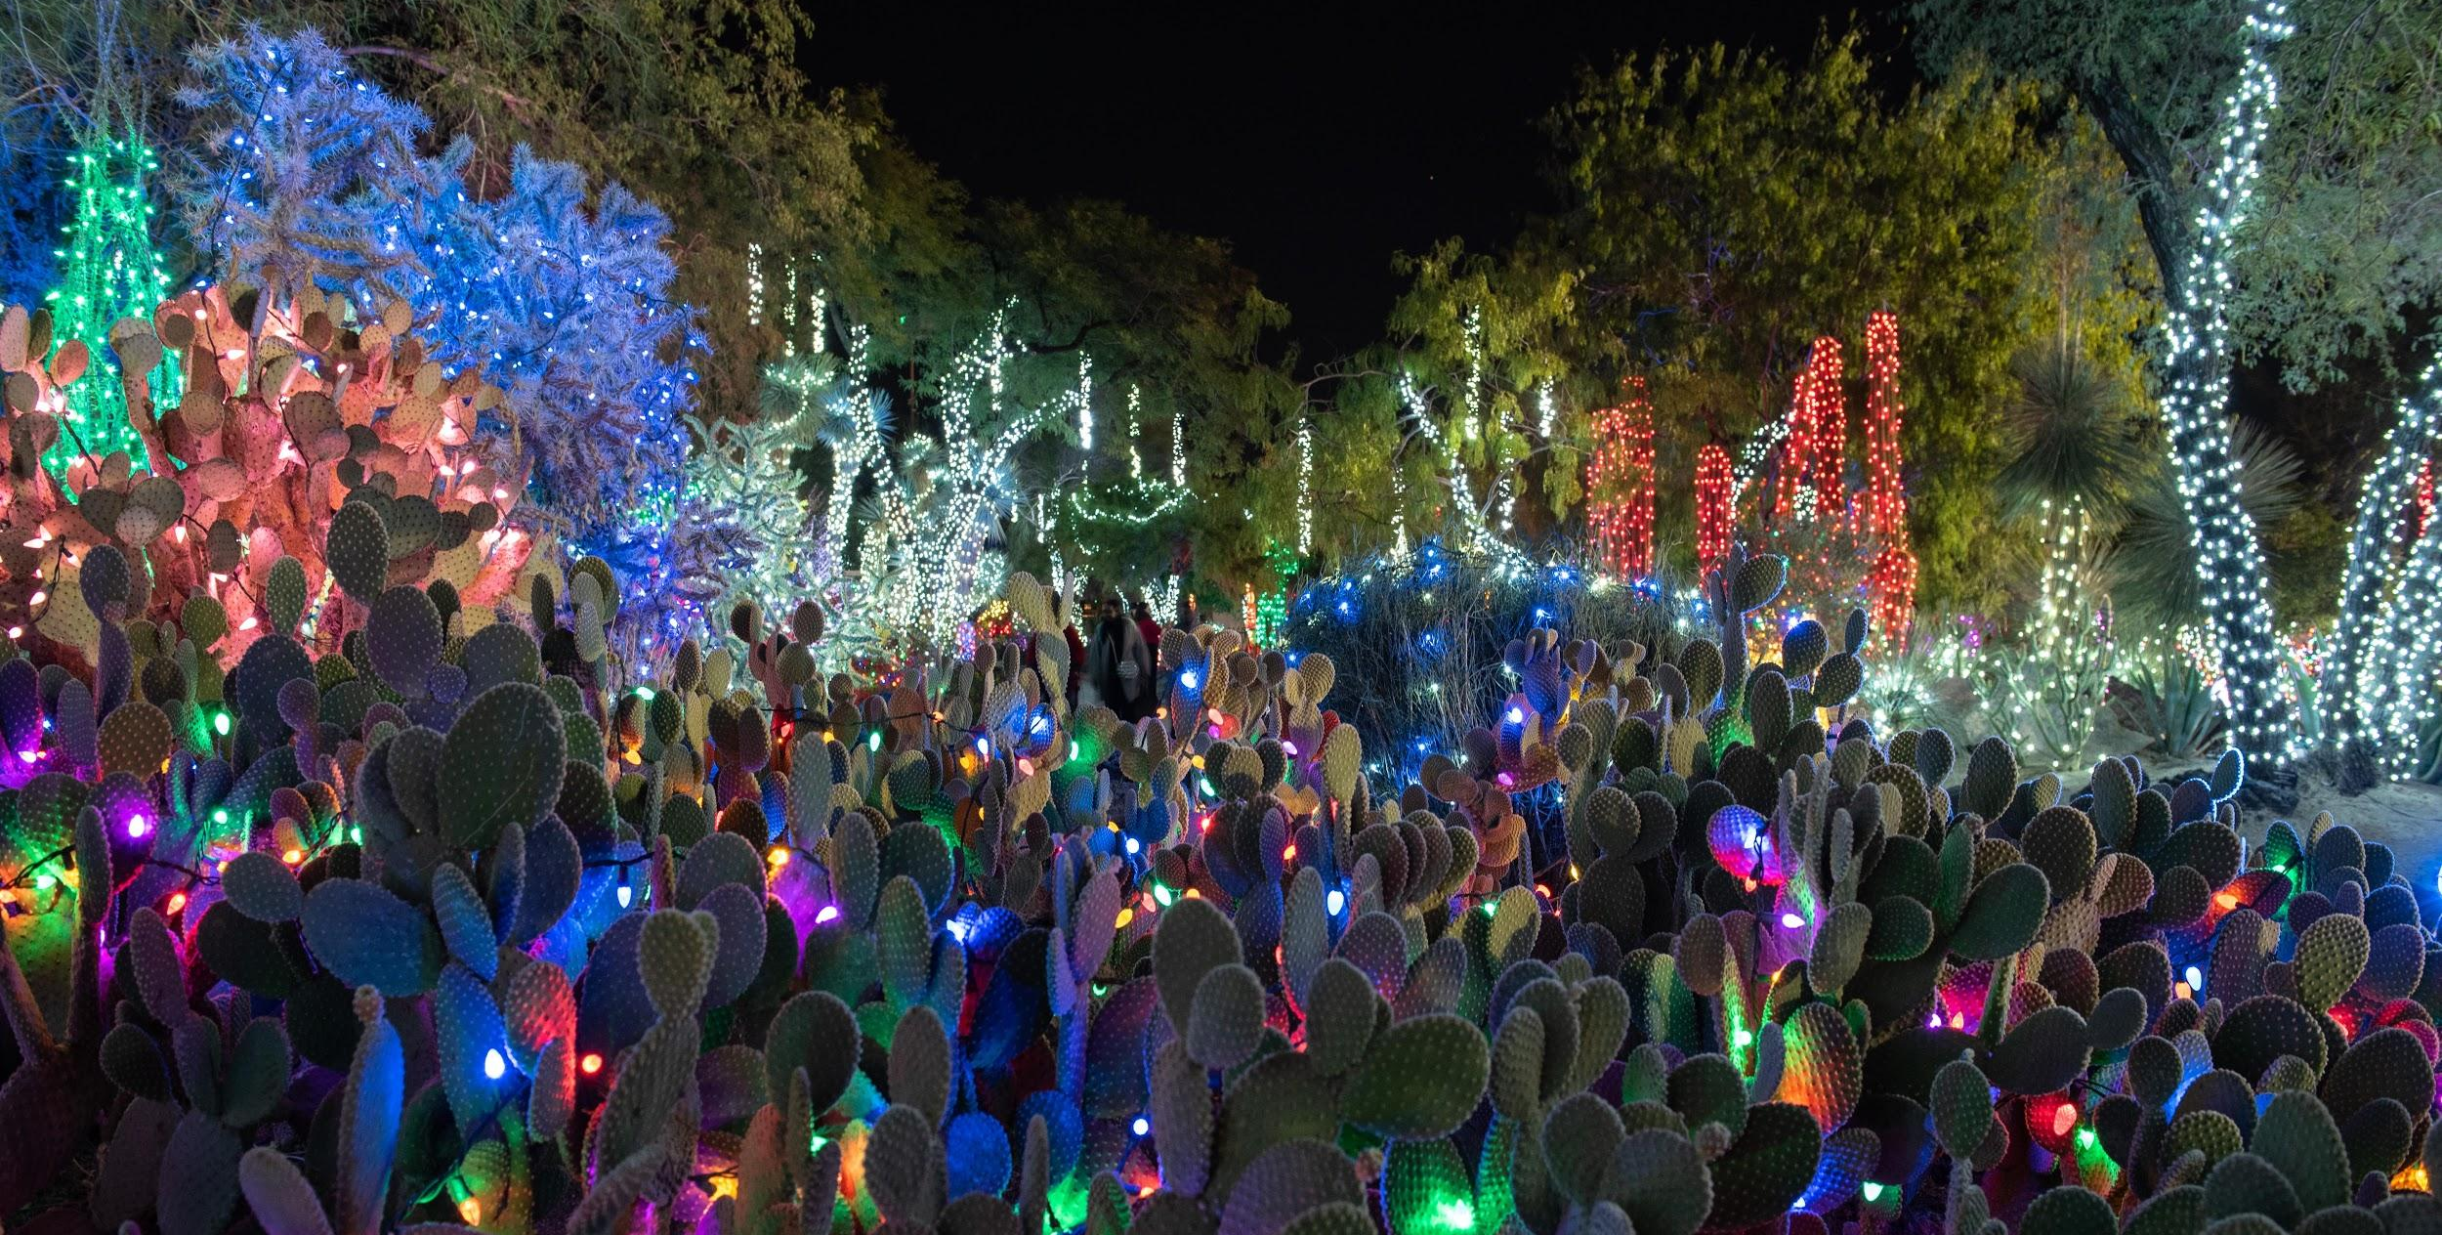

HENDERSON, Nev. (October xx, 2020) – With this holiday season projected to look much different than past years, Ethel M Chocolates, the Nevada-based craft chocolate division of Mars Inc., has reimagined its beloved Holiday Cactus Garden Lights to be a safe environment for holiday cheer. To launch the opening of the garden, the 27th Annual Cactus Garden Lighting Ceremony will take place virtually on Friday, November 6, while honoring Las Vegas first responders on-site with a private, drive-in event that night. The garden will then be opened to the remaining public from Saturday, November 7 to Sunday, January 3 with reservations required. Santa will also attend this year’s celebration and be available for pictures throughout the season.

“As it has become the local tradition to mark the start of the season with our Holiday Cactus Garden Lights, we are excited to present it in a new way that allows everyone to celebrate in a safe, memorable setting,” said Lisa Vannerson, Marketing and PR Manager at Ethel M Chocolates. “Ethel M Chocolates will continue to monitor the regulations surrounding COVID-19 and take the necessary precautions to keep our staff and guests safe during this joyous time of the year.”

What’s New
With so much new this year, Ethel M Chocolates has made the following adjustments to their holiday season:

- The 27th Annual Holiday Lighting Ceremony on Friday, November 6 at 5 p.m. options:
  - Register for a free Zoom link to watch the virtual experience.
  - A virtual VIP Package for the Holiday Lighting Ceremony is available for purchase.
  - This year’s exclusive drive-in Holiday Lighting Ceremony will be dedicated to local first responders who have helped keep Las Vegas moving during the pandemic.

- Free reservations are required from Saturday, November 7 – Sunday, January 3 to:
  - Visit the Holiday Cactus Garden Lights and see Santa throughout the season. Preorders for hot chocolate can be purchased online to avoid standing in lines. Masks are required.
  - Ensure a safe and fun experience, guests can take photos with Santa in front of the plexiglass window of his workshop.

- Reservations are not required to:
  - Shop in the Factory Store, however, masks are required.

Holiday Lighting Ceremony
The cherished Holiday Lighting Ceremony is going virtual via Zoom on Friday, November 6. Guests can participate by registering to watch the live experience, free of cost. A VIP package is also available for purchase at $55, which will include a link to watch the live event, a tin of premium hot chocolate with a live demo, two five-piece chocolate samplers and a live chocolate tasting with the Chief Chocolatier.

Additionally, Ethel M Chocolates would like to extend a special thank you to Las Vegas first responders with a chance to attend the exclusive drive-in event for the Holiday Cactus Lighting Ceremony. The chocolatier is hosting a social media contest allowing followers to nominate their local first responders, with 20 lucky winners to be randomly selected by Sunday, October 25. The VIPs will be invited to attend the ceremony on Friday, November 6, in their car along with five others, be treated to free hot chocolate and chocolate, walk the garden and take socially distanced photos with Santa.

Visiting the Holiday Lights
The tradition continues with the Holiday Cactus Garden Lights which will take place from Saturday, November 7 to Sunday, January 3. To ensure crowd control within state limitations, guests are required to book a free reservation between 4 p.m. and 9 p.m. daily at ethelm.com. Unfortunately, guests without a reservation will have to be turned away due to capacity constraints. To avoid lines in the store, Ethel M’s beloved hot chocolate can be pre-ordered online when booking a reservation. Masks are required at all times in the store and garden, with the exception being to take a drink, bite or photo.

Ethel M Chocolates is honoring Las Vegas first responders with the first look at their Holiday Cactus Garden Lights on Friday, November 6. This includes employees of hospitals, postal offices, pharmacies, trucking, schools, grocery stores, restaurant workers, etc.

Photos with Santa
Santa Claus returns to the Holiday Cactus Garden and is ready to check his list twice. The jolly old elf will be available for pictures while seated in his workshop with a plexiglass window between him and the kids. Please visit www.ethelm.com/seasonal-holiday-cactus-garden for exact dates and times for photos with Santa. Cashman will be taking professional pictures that will be available for purchase with packages starting at $20.

Guests who would like to visit the store to shop for gifts and not walk through the garden or see Santa are welcome to walk in without a reservation, but masks are required. For more information about Ethel M Chocolates’ holiday season please visit www.ethelm.com.

About Ethel M Chocolates
Ethel M Chocolates are manufactured by Mars Chocolate North America, dedicated to creating authentic chocolates with no artificial preservatives. Ethel M Chocolates are available in multiple locations throughout Southern Nevada, online at www.EthelM.com, or by phone at 800-438-4356. The Ethel M Chocolate Factory and Botanical Cactus Garden are located at 2 Cactus Garden Drive in Henderson. For more information on the Botanical Cactus Garden, events, store hours, locations and ordering products, please visit us online or follow us on Facebook, Twitter, Instagram and Pinterest.

About Mars, Inc.
Mars is a family-owned business with more than a century of history-making diverse products and offering services for people and the pets people love. With almost $35 billion in sales, the company is a global business that produces some of the world’s best-loved brands: M&M’s®, SNICKERS®, TWIX®, MILKY WAY®, DOVE®, PEDIGREE®, ROYAL CANIN®, WHISKAS®, EXTRA®, ORBIT®, 5TM, SKITTLES®, UNCLE BEN’S®, MARS DRINKS and COCOAVIA®. Mars also provides veterinary health services that include BANFIELD® Pet Hospitals. Headquartered in McLean, VA, Mars operates in more than 80 countries. The Mars Five Principles – Quality, Responsibility, Mutuality, Efficiency and Freedom – inspire its more than 85,000 Associates to create value for all its partners and deliver growth they are proud of every day.
For more information about Mars, please visit www.mars.com. Join us on Facebook, Twitter, LinkedIn, Instagram and YouTube.

###

Media Contact:
BRAINTRUST
Iolanda Focsa, 702.882.0312
iolanda.focsa@braintrustagency.com

